Wise Words
Gary Wise
With the last couple installments of this here column having been based mostly on making the lot of you a little better prepared for competition, this week I'm going to do everything in my power to avoid talking about strategy and focus on the other stuff: tourney goings on, a little gossip and a look at CCGPrime's War of the Internet Writers.
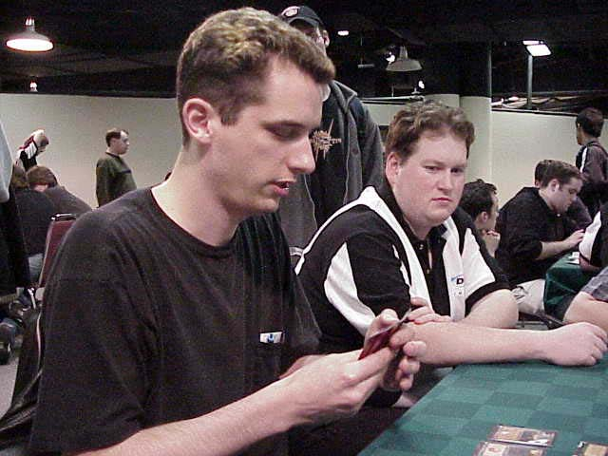
We start this week with a look at the events surrounding Matt Vienneau's win in Detroit. Without taking away from the considerable achievement of winning two GPs and making Top 4 in a third in one season, it's interesting to note that Vienneau's appearance in Top 8 would never have happened if not for the events occurring in the 14th round.
Playing what he felt was a suboptimal deck, Justin Schneider sat down for his final round match against 15 year old Ben Stoll. With Justin needing a win to get to the 34-point plateau that was expected as the watermark for the Top 8, the two came to a financial agreement that would see Stoll, who already had 34 points, throw the match to Justin. After what appeared to be a very sketchy finish to the match, judges made an inquiry into the matter and found out what was going on, disqualifying both players from the tournament.
The indirect result of this was Vienneau and Dan Clegg finding their way into the Top 8. The direct result may include suspensions for either or both players. This would likely mean the end of Schneider's comeback. Justin, who was once among the most dominant juniors on the planet, had apparently been lured back into the competitive game by the financial opportunities the Pro circuit offers.
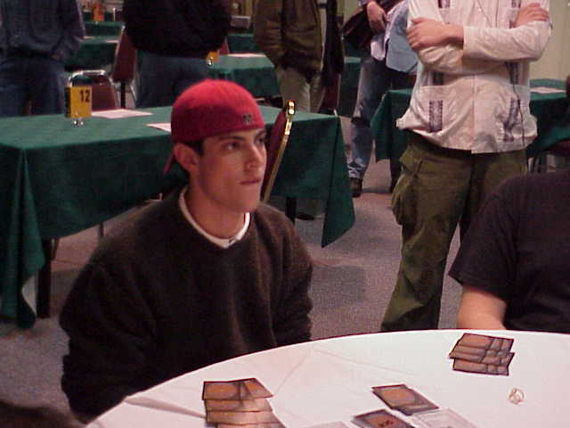
Justin started out on top and stayed there for a long time. Finishing 9th in the Juniors at the first Pro Tour in New York, he followed this up with a 6th place finish in Columbus that season and a win at Dallas over Jeremy Baca. With nothing left to prove in the Juniors, Justin graduated to the senior circuit, where he immediately made his mark with a 32nd place finish at New York before making the Top 8 at 1997 Pro Tour-Chicago.
Closely affiliated with the likes of Tongo Nation teammate Mike Long and brother Brian Schneider (now working in R&D), Justin's career came to a premature end at Pro Tour-Rome, where it was discovered he was playing under a DCI number other than his own. It seems likely that the resulting suspension will contribute to the DCI's attitude towards how to treat this latest infraction.
Justin's comeback had him playing Magic nightly and traveling to GPs. In Rio, he looked like his old unstoppable self, dominating the Swiss rounds before losing in the semifinals. Unfortunately, he broke the rules in Detroit, regardless of anything else. I like talking to Justin about the game and he's clearly an enthusiastic, smart guy. It's too bad that he committed actions that will force his demise.
With that said, just because Matt Vienneau found an unusual route to the Top 8, it doesn't diminish his accomplishments. Only Chris Benafel has come close to matching Matt's record during this GP season, and while, as tournament reports indicate, Vienneau's play hasn't been spotless, his drafting has been very strong and for that he deserves credit.

Enemy or no?
In other news, www.CCGPrime.com is holding a fun little contest called the War of the Internet Writers. As I write this, the internet community is judging Alex Shvartsman and me, pitting us against one another in a vote that is supposed to determine which of us is the better writer. By this time this installment of Wise Words hits the Sideboard, the voting period should be drawing to an end, so I don't mind putting a little focus on the event as a whole.
As things stand, the field is down to twelve and soon will be down to eight. The reason I've chosen now to comment on it is because it seems that www.StarCityGames.com editor-in-chief The Ferret has taken it upon himself to promote the contest whole-heartedly, and this seems to be giving his writers an unfair advantage. He must be stopped.
So, I'm urging each of you to go and vote for whomever you feel deserves it. Go ahead, cast your votes and mock the contest that "Only the writers care about." If nothing else, it's fun to see how the votes go, and the 200 hundred some-odd votes they're getting on each match right now is hardly enough to make a distinction (Not that good writing can be determined by public consumption vote. Each of the writers still in is more than capable with a keyboard) so your vote will add some beef to it. If nothing else, I think the contest goes to serve notice about whose writing the public likes. Hey, maybe you'll find out about a writer whose work you never had the opportunity to read before.
As for me, I see Anthony Alongi winning the whole thing. Just a hunch mind you, and it'll be tough for him to get by John Rizzo next round, but I just have this feeling...
Speaking of Rizzo, I finally met the man this weekend. John and I have corresponded a few times and we have some mutual friends in Pittsburgh, but we'd never actually met. Well, those of you who want to know what he's really like won't be disappointed by bawdy language that was used in the fifty words he said to me. The man writes what he is.

The question lies in how you should assemble your team...
I received a couple of e-mails over the last week that I felt I should address here. The first asked the question of how to assemble a good team for Team PT and PTQ purposes. I think it important to remember when entering this kind of relationship that trust is the most important part of the relationship. Not only to you need to be able to trust your teammates' play styles, but you also need to be able to trust them to be responsible, showing up for each practice and tournament round.
On top of this, you have to assess team strengths and weaknesses with your choices. When Mike Turian and I were looking for a third when forming Potato Nation, we realized that we felt comfortable with the Team Rochester format (Mike is especially strong at this), but neither of us had a lot of experience with Team Sealed, or more specifically the division of the cards in building our decks. Scott, who has really been around a lot longer than either Mike or I, had a lot of experience with this kind of work from back in his days with PCL (considered by most to be the first great team, PCL, or Pacific Coast Legends, included Scott, Preston Poulter, Mark Justice, Henry Stern, Mario Robaina, Frank Gilson and a host of others) and as a result, he became the logical choice for the spot.
Now of course, for most the problem lies not in which strong professional player to work with, obviously Mike and I were lucky in this respect. More realistically, the question lies in how you should assemble your team. Simply, you have two choices: either play with friends whose games you know are on a par with yours, or play with the best players you can find, regardless of friendship.
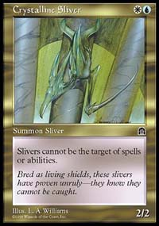
If you can incorporate both into your decision, then you're going to be well off. Not only will you have the luxury of being on a strong steam, but also you'll have no problems spending the ample time needed to prepare with one another. Obviously, if you can't have the best of both worlds, you're going to have some difficulties to overcome.
Playing with friends will definitely be the more enjoyable alternative, but if you're serious about winning, there will be times where you'll have to put winning aside. If you have a problem with the way one of your teammates is drafting or playing, you're going to have to make a choice; either preserve your friendship and keep it to yourself, or confront them at the risk of alienation.
Playing with serious players who you don't particularly get along with however will provide opposite difficulties. Like with any endeavor, if you want to succeed in Magic, you have to get your hands dirty, spending a lot of time practicing and preparing. Spending that much time with anyone can be taxing, so if they're people you don't particularly like, the results could be devastating to your efforts. In short, when deciding on who your teammates are, you really have to weigh how important factors like friendship, fun and winning are to you. If you can answer that question, picking your teammates shouldn't be hard.
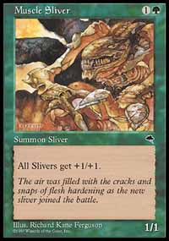
The second question I received in my e-mail concerned those players who are lucky enough to get to the Pro Tour. The question asked how a player who was lucky enough to break through would then be able to compete with large pro teams that are full of expert deck builders and top players.
This may be a rude awakening for some of you, but making the Pro Tour is only the beginning. You may want me to tell you that once you get there life is sunshine, lollipops and roses, but the simple fact is it's a lot harder to stay on Tour than to qualify. No, I'm not belittling the effort required to qualify, but if you're the big fish in your little pond and prove this is true by winning a PTQ, the Pro Tour is an ocean, and there are a lot of big, dangerous fish.
Very simply, Magic is a lot like baseball in the ways the Minor Leagues and Major Leagues differ. The money is a lot bigger, yes, but that means the competition is a lot fiercer. Baseball rookies go through a certain amount of torment year in and year out, and while the actions of PT veterans may not be as blatant, each new applicant to the gravy train has to prove themselves as a fresh major league call-up would have to, or risk being sent back to the minors.
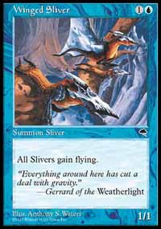
The math is easy here. With 300 or so players competing for 64 prizes, and with only 32 requalifications to go around for around 250 of those competing who aren't qualified for the next PT stop, the 'pros,' or those people who keep showing up in this column, have to be careful about who they work with. With opportunities so limited, one can not merely start throwing information around to whoever asks, because simply, when you start playing a game for $150,000, it elevates itself to more than just a game.
So, with this rude awakening firmly established, the question is how one handles the transition from PTQ winner to successful PT participant. The first and most obvious answer here is to affiliate yourself with professional players before the day comes where you make your first PT. In my case, I started playing with Gab Tsang, Eric Tam and the other Toronto professionals long before I made my first PT, helping them with play testing, hosting drafts and the like. By the time I qualified for PT Dallas, I'd been working with them long enough that my working with them for Dallas was a foregone conclusion.
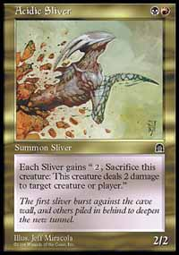
If you haven't been fortunate enough to be in a position to work with pros in your area, the best way to get in touch with other high level players is online. While not every pro on line is unaffiliated, for every gravy trainer you'll find there, you'll find five players who are on the brink of the pro tour and who are looking for help in the same way you are. On IRC's Efnet, channels like #mtgwacky, #mtgplay, #netdraft and #mtgpro (where more often than not, you'll get a not so welcome greeting-just warning you) are chock full of players who are looking for that one little piece of information that can further propel them to PT greatness. These people will not be able to serve as your mentors so much as your colleague. Instead of learning from a better player, you'll learn with one who is on par.
Basically, if I were trying to prove myself on the Pro Tour right now, I would take any help I could get. Secrecy protects that information you have, but it also guards you from that information that can help you. With the World's best grouping themselves together in order to protect their own, the best way to beat their superior firepower is likely to be by outnumbering them. Open yourself to new people, and with them, new ideas. Once you show the world what you can do, you can get a little pickier about who you work with, if that's what you want to do.
That's it for this week. As always, if you have any questions or comments about the content of this column, feel free to e-mail me at JGaryWise@yahoo.com. Next week, I'll have a report from "PT Wisconsin" (Bob Maher's wedding) and some other good stuff. Have a good week.

